WSTG Notes
Prepared by: Shujah Ullah
Course: DCCS (WSTG)
web security testing guide:

OWASP:
Open Web App Security Project is open source project aiming securing web apps.
There are various projects initiated by owasp.org as listed below:

OWASP TOP 10: https://owasp.org/Top10/
Top 10 webApp security Risks:

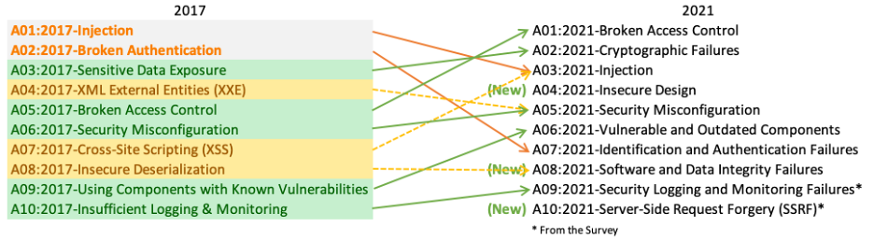
OWASP Juice Shop: https://owasp.org/www-project-juice-shop/
OWASP Juice Shop is probably the most modern and sophisticated insecure web application! It can be used in security trainings, awareness demos, CTFs and as a guinea pig for security tools! Juice Shop encompasses vulnerabilities from the entire OWASP Top Ten along with many other security flaws found in real-world applications!
- OWASP Mobile App Security https://mas.owasp.org/
The OWASP Mobile Application Security (MAS) flagship project provides a security standard for mobile apps (OWASP MASVS)

OWASP SAMM https://owasp.org/www-project-samm/
mission is to provide an effective and measurable way for you to analyze and improve your secure development lifecycle.

OWASP CRC https://owasp.org/www-project-modsecurity-core-rule-set/
The 1st Line of Defense Against Web Application Attacks
The OWASP CRS is a set of generic attack detection rules for use with ModSecurity or compatible web application firewalls. It aims to protect web applications from a wide range of attacks, including the OWASP Top Ten, with a minimum of false alerts. CRS provides protection against many common attack categories, including SQL Injection, Cross Site Scripting, Local File Inclusion, etc.

OWASP WSTG https://owasp.org/www-project-web-security-testing-guide/
WSTG web security testing guide is comprehensive guide for testing Web Apps & Web Services.
---------------------------------------------------------------------------------------------------------------------------

WSTG Summary:
WSTG guide mainly consist of following topics
1. Web security testing Frame work.
2. Penetration testing Methodologies.
3. Web App Security Testing.

1. Web App security Testing Frame Work
This testing framework consists of activities that should take place in various phases of SDLC:
Product Development Life cycles :
- System development Life cycle.
- Software Development Life Cycle.
Web security testing frame work provides guide to test Web Apps at each phase of Software development Life Cycle (SDLC).
Typical testing phase in correlation with SDLC consist of following steps:
- Before development begins
- During definition and design
- During development
- During deployment
- During maintenance and operations.
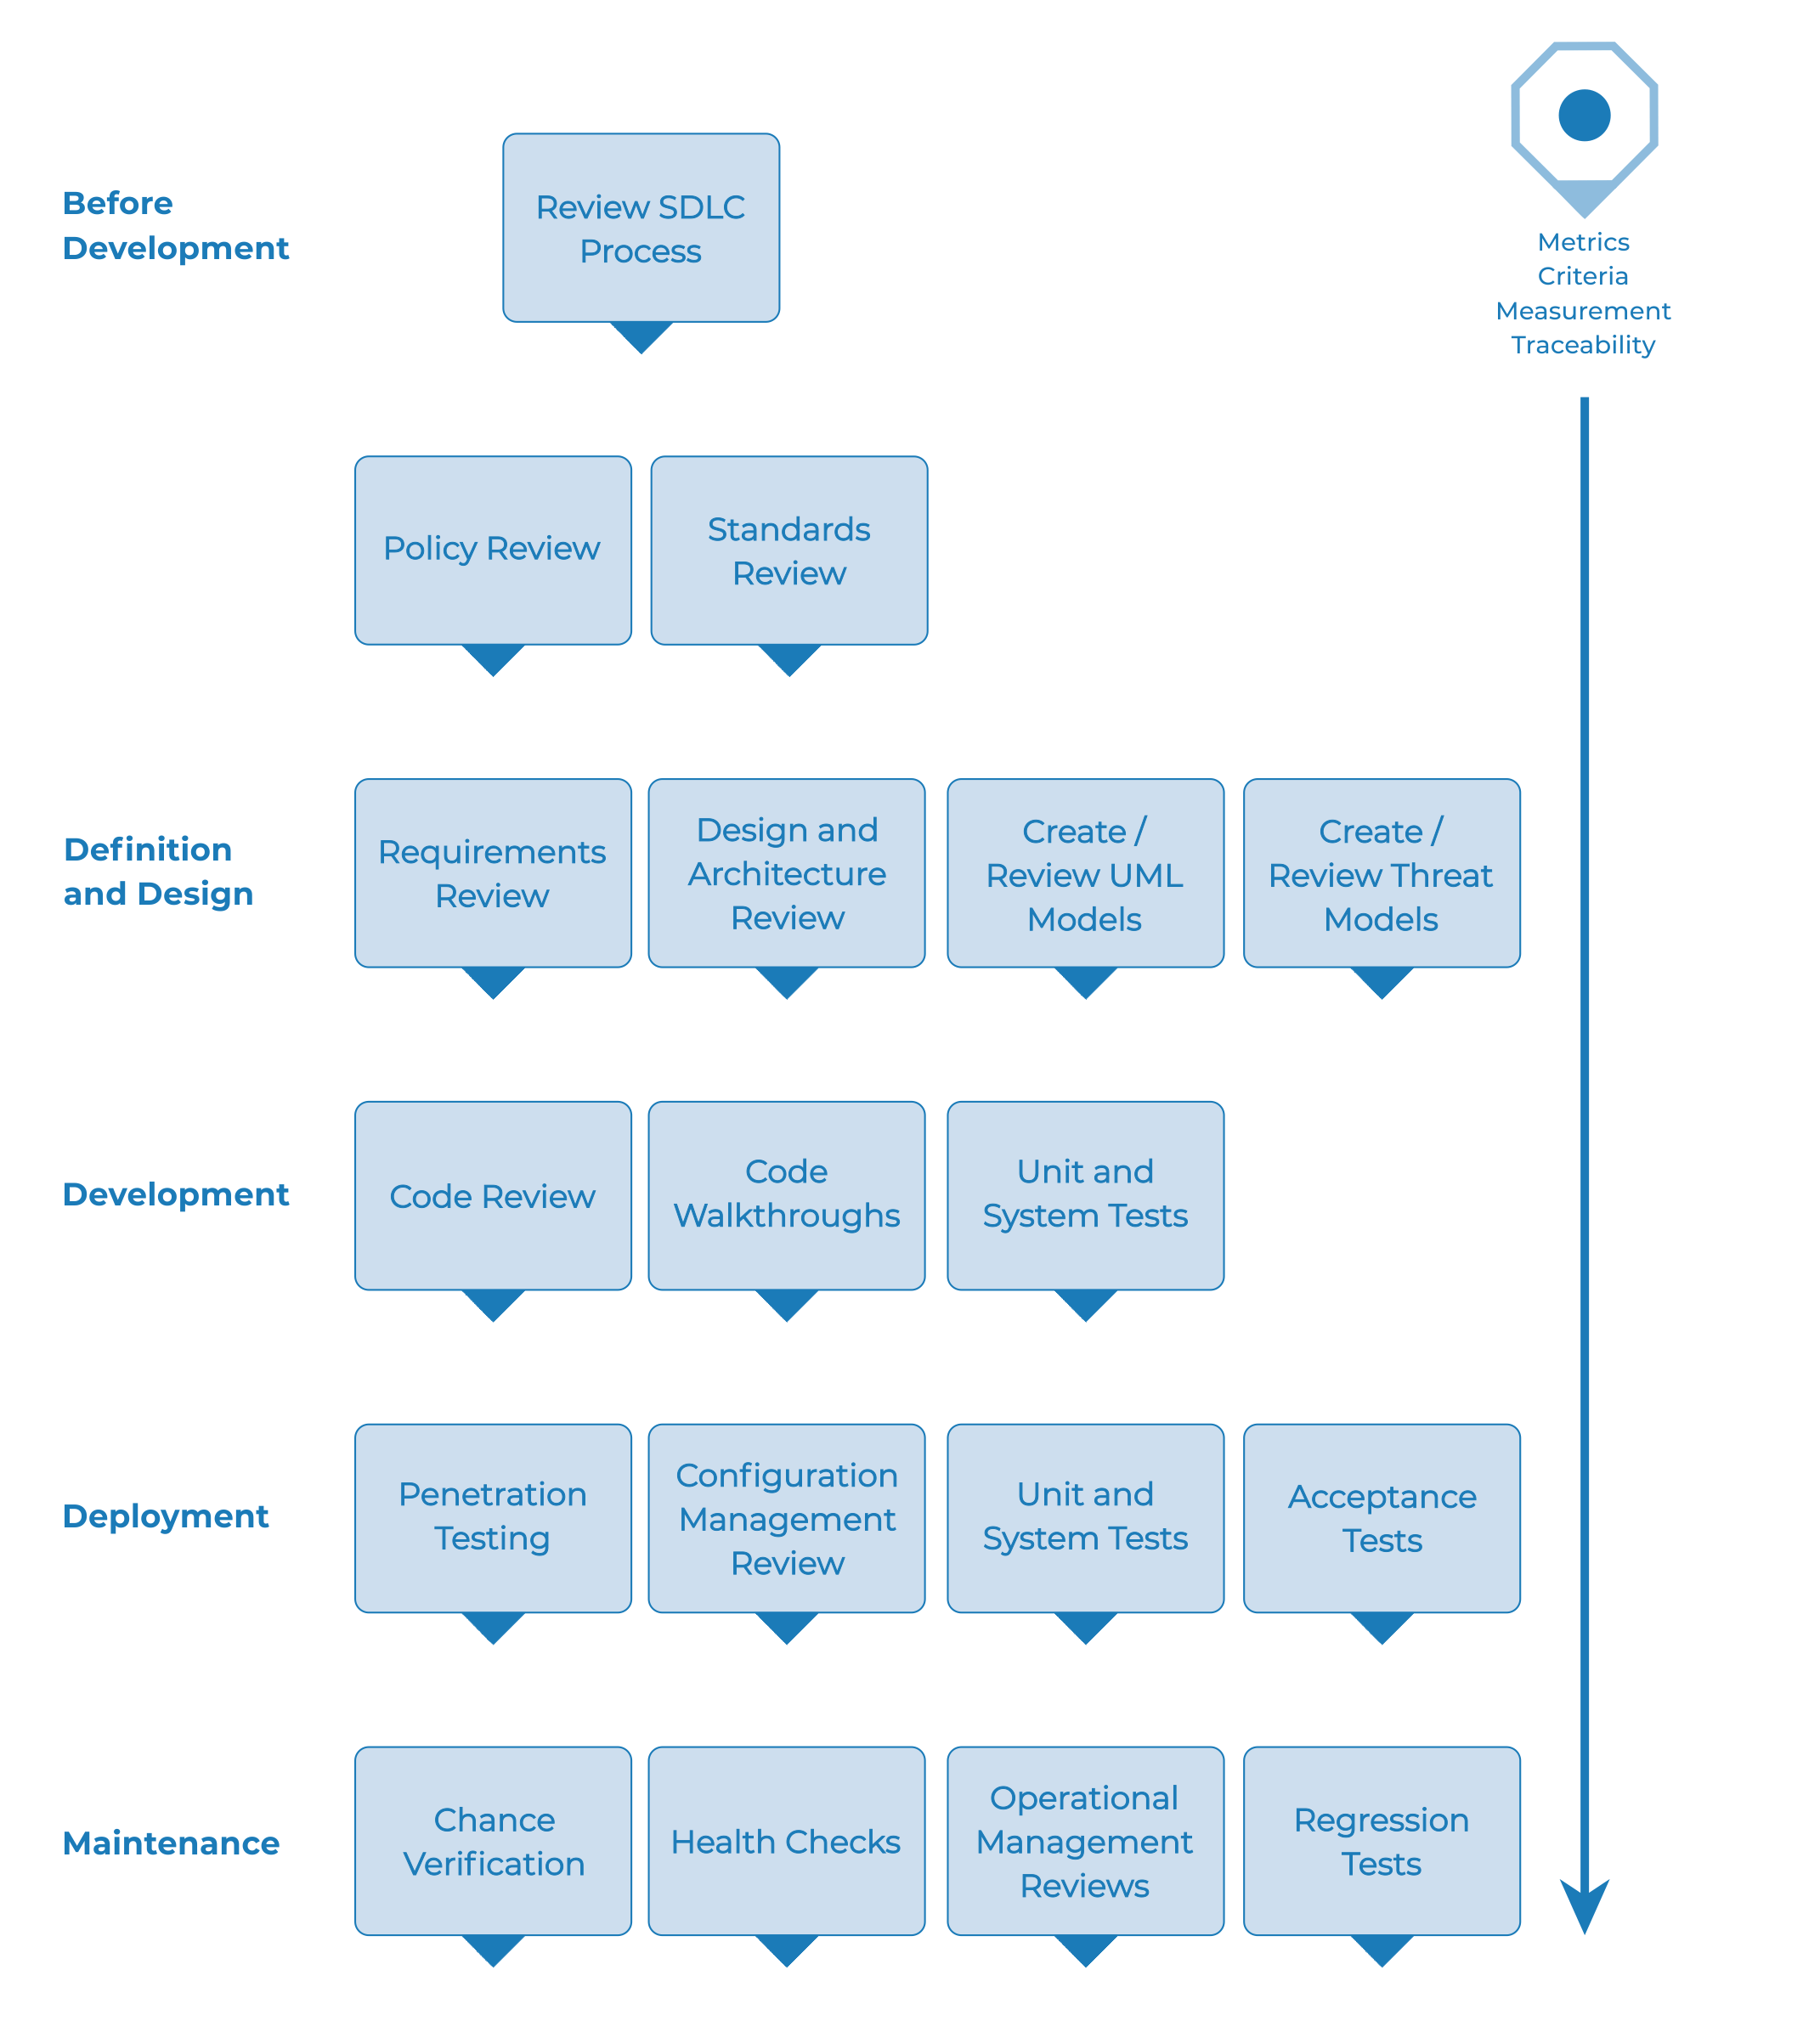Figure 1: Web App Testing on each phase of SDLC
1. Before development begins:
Define SDLC
Review Policies & Standards
Develop Measurement and Metrics Criteria and Ensure Traceability
2. During definition and design
Review Security Requirements
Review Design and Architecture
Create and Review UML Models
Create and Review Threat Models
Code Walk Through
Code Reviews
3. During deployment
Application Penetration Testing
Configuration Management Testing
4. During maintenance and operations
Conduct Operational Management Reviews
During maintenance and operations.
Ensure Change Verification
------------------------------------------------------------------------------

2. Penetration testing Methodologies:
Summary :
There are different Different guides, Frameworks & standards for Penetration testing, they include.
- OWASP Testing Guide
- PCI Penetration Testing Guide
- Penetration Testing Execution Standard
- NIST 800-115 Penetration Testing Framework
- Information Systems Security Assessment Framework (ISSAF)
- Open Source Security Testing Methodology Manual (OSSTMM)
--------------------------------------------------------------------------------------

3. Web App Security Testing.

Active testing vs Passive Testing:

Passive Testing
Definition: Passive testing involves gathering information about the target web application without directly interacting with it in a way that would alter its state or performance.

Active Testing
Definition: Active testing involves direct interaction with the target web application by sending requests, input, or other data to identify vulnerabilities and test the system’s security controls.

Comparison Table: Passive vs Active Testing
Aspect | Passive Testing | Active Testing
Interaction with System | No direct interaction, non-intrusive. | Direct interaction with the application, intrusive.
Risk | Minimal risk, no effect on the target system. | Moderate to high risk, can disrupt the application.
Techniques | WHOIS lookup, DNS interrogation, traffic analysis. | Brute force, SQLi, XSS, port scanning, session hijacking.
Detection of Vulnerabilities | Limited to information gathering, no vulnerability detection. | Actively finds vulnerabilities like SQLi, XSS, and authentication flaws.
Stealth | Very stealthy, unlikely to trigger security alerts. | Likely to trigger security defenses and logs.
Purpose | Gather initial intelligence and identify potential targets. | Identify and exploit vulnerabilities within the web application.
Tools | Tools like WHOIS, Shodan, Wireshark. | Tools like Burp Suite, OWASP ZAP, Nmap, SQLMap.

Both passive and active testing are essential parts of a complete web security assessment. Passive testing helps build an understanding of the application and infrastructure, while active testing directly engages with the system to find vulnerabilities.

11 categories of Testing web app as per WSTG:
Yellow = Passive testing
green = Active testing
ID | Section | Key Concepts | Purpose
WSTG-INFO-XX | Information Gathering | WHOIS, DNS lookup, Port Scanning, Fingerprinting | Identifying the technologies and structure of the target web app for focused testing.
WSTG-CONF-XX | Configuration Testing | Server Misconfigurations, Default Passwords, Exposed Interfaces | Ensuring secure configurations and deployment of applications and infrastructure.
WSTG-IDNT-XX | Identity Management Testing | Authentication Bypass, MFA, Weak Password Policies | Testing how the app manages user identities and credentials.
WSTG-AUTHN-XX | Authentication Testing | Brute Force, Session Management, Login Security | Ensuring secure authentication methods and preventing unauthorized access.
WSTG-AUTHZ-XX | Authorization Testing | Privilege Escalation, Access Control | Testing for vulnerabilities in user role management and access controls.
WSTG-SESS-XX | Session Management Testing | Session Expiration, Cookie Security, Session Hijacking | Securing session handling and protecting session tokens from attacks.
WSTG-INPV-XX | Input Validation Testing | XSS, SQL Injection, File Upload Security | Preventing attacks that result from improper handling of user input.
WSTG-ERRH-XX | Error Handling | Sensitive Information Disclosure, Misconfigured Exception Handling | Securing error messages to avoid leaking sensitive information.
WSTG-CRYP-XX | Cryptography Testing | Weak Encryption, SSL/TLS Misconfigurations | Ensuring encryption is correctly implemented to protect data at rest and in transit.
WSTG-BUSL-XX | Business Logic Testing | Workflow Exploits, Payment Bypassing, Logical Flaws | Identifying flaws in the business logic and processes that can be exploited.
WSTG-CLNT-XX | Client-Side Testing | JavaScript Vulnerabilities, CORS Issues, Browser Security Flaws | Securing client-side code to prevent attacks targeting the browser and client-side interactions.

Note: Through out WSTG course we will perform these testings in lab environment.

----------------------------------------------------------------------------------------------------------------------
WSTG-INFO-01: Search Engine Discovery Reconnaissance for info Leakage.

Search Engines
Google, duckduckgo, baidu, shodan, binsearch.info, startpage

Search Operators => operator:query
site: will limit the search to the provided URL.
inurl: will only return results that include the keyword in the URL.
intitle: will only return results that have the keyword in the page title.
intext: or inbody: will only search for the keyword in the body of pages.
filetype: will match only a specific filetype, i.e. png, or php.

site: owasp.org
cache:owasp.org
ethical hacking tools intitle: "top 10"
intitle:"SQL Injection" inurl:guide

Google Hacking or Dorking https://www.exploit-db.com/google-hacking-database
Operators can be chained to effectively discover specific kinds of sensitive files and information. This technique, called Google hacking or Google dorking.

Lovely google Dorks.
intext:"aws_access_key_id" | intext:"aws_secret_access_key" filetype:json | filetype:yaml | Files containing Pwds

WSTG-INFO-02: Web server fingerprinting
Web server fingerprinting is the task of identifying the type and version of web server that a target is running on.
Techniques used for web server fingerprinting include banner grabbing.
Techniques for banner grabbing are:
inspect webpage and in network section navigate HTTP response header.
Tools used are:
Wappalyzer https://www.wappalyzer.com/
netcraft https://www.wappalyzer.com/
Nikto nikto -h <target_ip_or_url>
Nmap nmap --script=banner <target_ip>

WSTG-INFO-03: Review Webserver Meta files for information leakage:
Examine Robots.txt file.

WSTG-INFO-04: Enumerate Applications on Web Server:
next step is to identify entry point addresses of web apps, usually web apps arent directly hosted on server IP address but we may face various hurdles to identify exact entry point to web app.
Web apps may be deployed with
a) Different base URLs
b) Non standard ports
c) Virtual hosts

a) Exploring subdomains & Non Standard URLs
site: website.com
b)Exploring Non standard Ports
Use Nmap to scan all TCP opened ports and explore nonstandard ports further:
nmap –PN –sT –sV –p0-65535 192.168.1.100
use telnet to explore non-recognized ports.
c)Identify name-servers of host
host -t ns vulnweb.com
whois <ip address>
nslookup <website>
a very detailed dns tools: https://viewdns.info/
tracert <ip or host>

WSTG-CONF-XX configuration & Deployment Management Testing:

WSTG-CONF-01 Test file extensions for senstive info:

Robots.txt specifies all files that are accessible for browsing and files that aren’t accessible/crawled by browser for indexing.
To search that files we can use file extensions in url: www.example.com/file-extension
Technique is called fuzzing.
Wordlists for fuzzing:
Seclissts: https://github.com/danielmiessler/SecLists

Tools for fuzzing:
1. In OWASP ZAP we have tool called forced browse which can be installed as extension in OWASP ZAP.
2. BURP SUITE by PortSwigger

fuzzing for misconfigured admin panel interfaces
inurl: wp-admin/
fuzzing using seclists+BURP SUITE payload.

WSTG-CONF-02 Test HTTP Methods:

HTTP METHODS: GET, POST, DELETE, PUT, DELETE, CONNECT, OPTION, TRACE.

WSTG-CONF-03 Test for Sub Domain TakeOver:

nslookup
DNSRecon
Sublist3r

